

**ACTIVITY REPORT**

**ON**

**SAMANVAYA #1**

1. **Name of the Club:** BMSCE ACM STUDENT CHAPTER
2. **Name of the Activity:** SAMANVAYA #1
3. **Objectives:** The BMSCE ACM Student Chapter organized a community service event, SAMANVAYA #1 - Together for Change, as an initiative to give back to society. The event aimed to instill a sense of social responsibility among members while making a meaningful impact. A donation was made to provide lunch for 72 children at an orphanage, emphasizing the power of collective efforts in bringing change.
4. **Date, Time Venue of the Activity:**

| **EVENT** | Samanvaya #1 |
| --- | --- |
| **DATE/DAY** | Thursday, 13th March 2025 |
| **TIME** | 4:30 am to 5:00 pm |
| **VENUE** | Amrutha Shishu Nivasa, NR Colony, Basavanagudi, Bengaluru. |

1. **Name and details of collaborating agency (if it is collaborative/joint activity):** None
2. **Brief summary of the Event:**

The BMSCE ACM Student Chapter initiated its journey in community service with SAMANVAYA #1 - Together for Change on March 13, 2025. The event involved a donation drive where funds were collected from the members to provide lunch for 72 children at Amrutha Shishu Nivasa, an orphanage in Bengaluru.

* The donation amount was ₹2,000, out of which ₹1,000 was contributed through member donations, and ₹1,000 was allocated from the chapter’s treasury.
* A total of 14 members contributed financially, while 5 members visited the orphanage to deliver the donation and spend time with the children.
* This initiative marked the beginning of the club’s commitment to community welfare, reinforcing the belief that small efforts can create a lasting impact

1. **Outcomes:**

Encouraged social responsibility and community engagement among members. Fostered a sense of empathy and contribution towards underprivileged children. Strengthened the teamwork and initiative of the BMSCE ACM Student Chapter beyond technical activities. Set a precedent for future community service initiatives under the SAMANVAYA series.

1. **Number of participants:**

| **Number of Donors** | **Number of Volunteers who visited the orphanage** |
| --- | --- |
| 14 | 5 |

1. **Photographs of the event:**

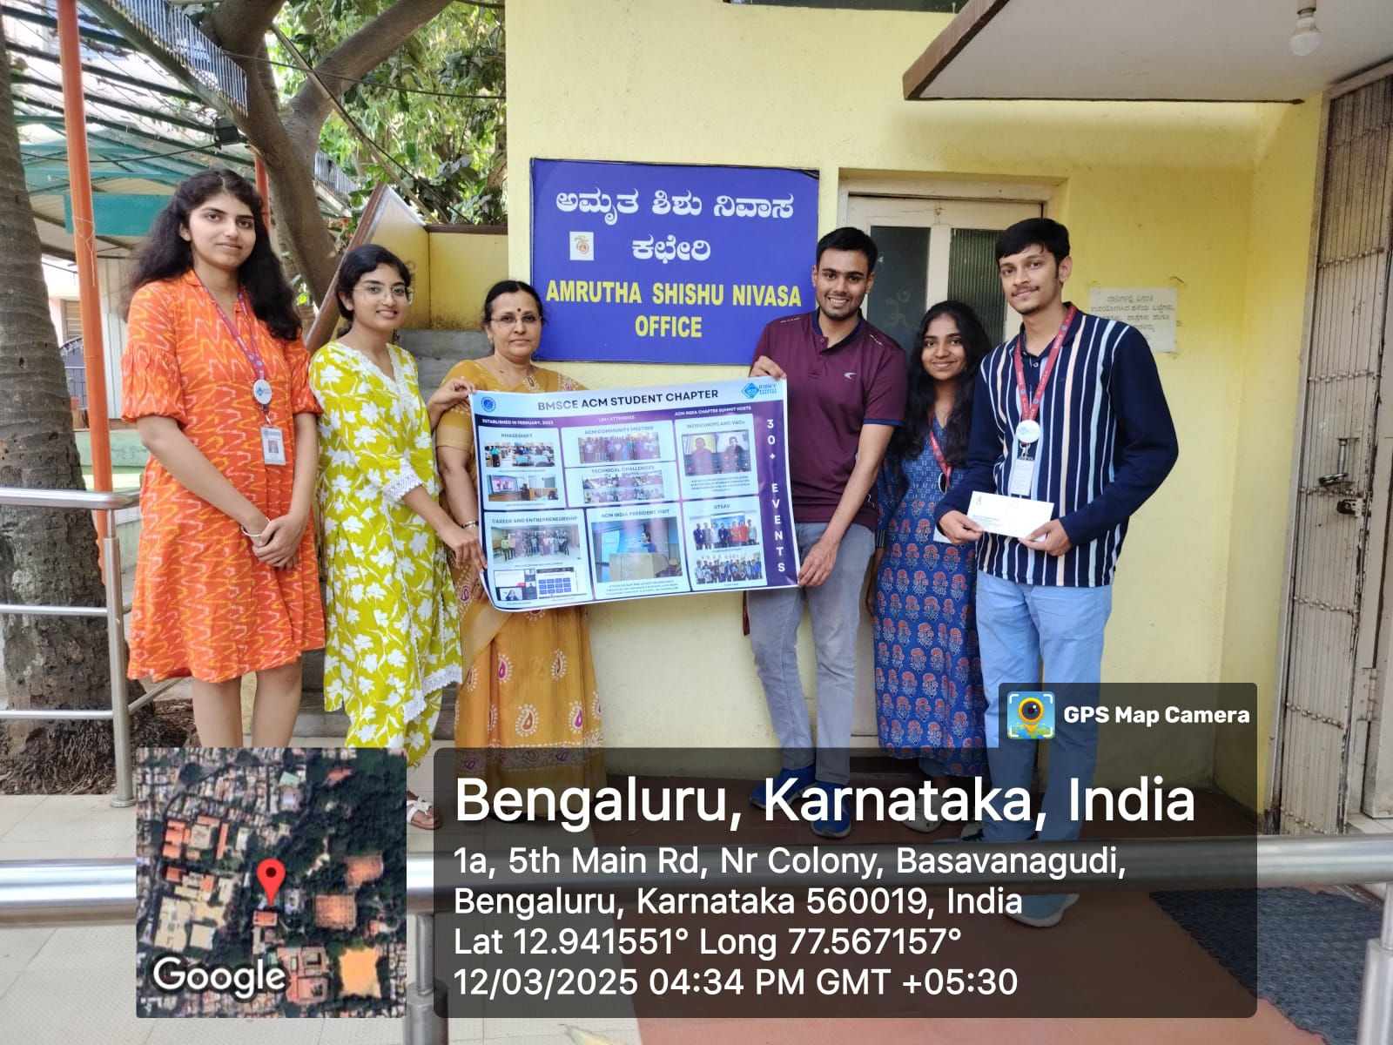

1. **Supporting Documents:**

**a.** **Circulars/Brochures:**

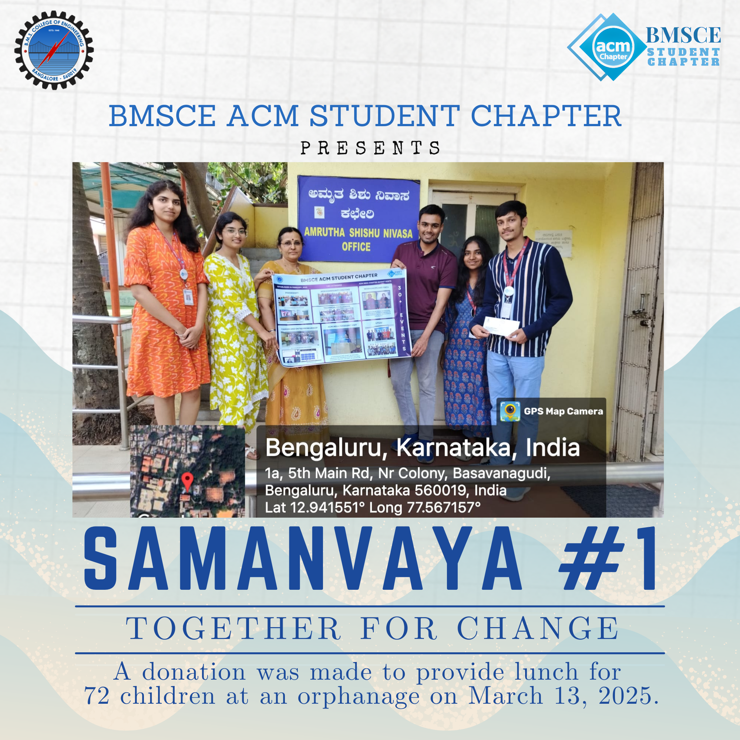

**b.** **Attendance:**